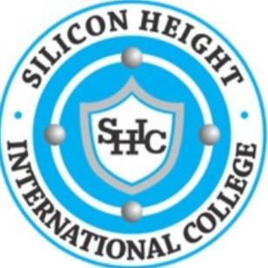

**SILICON HEIGHT INTERNATIONAL COLLEGE**

**(*Developing functional digital skills)***

No. 1 Turaki Sani Stores Road, Commercial Layout, Gidan Dawa, Katsina

**2025/2026 Academic Session: First Term Activity Planner**

|  |  |  |  |
| --- | --- | --- | --- |
| Weeks | Days | Date | Activities |
| 1 | Monday | 1st September, 2025 | Resumption |
| Thursday | 4th September, 2025 | College Policy Awareness |
|  | Friday | 5th September, 2025 | Eid-El- Maulud |
| 2 | Thursday | 11th September, 2025 | Carrier Counselling to all students |
| 3 | Mon-fri | 15th-19th Sept, 2025 | Lesson continues |
| 4 | Mon – Fri | 22nd – 26th Sept, 2025 | First C.A Week |
| 5 | Wednesday | 1st October, 2025 | Nigeria’s 65th Independence day |
| Friday | 3rd October, 2025 | Inter House Quiz Competition |
| 6 | Friday | 10th October, 2025 | Spelling Bee |
| 7 | Monday | 13th October, 2025 | International Cancer Day |
| Wed – Fri | 22nd – 24th Oct, 2025 | Mid Term Break |
| 8 | Mon – Fri | 29th – 31st Oct, 2025 | 2nd C.A Test |
| 9 | Mon – Fri | 3rd -7th Nov,2025 | Lesson continuous |
| 11 | Thursday | 13th November, 2025 | Inter Class Debate Competition |
| 12 | Friday | 21st November, 2025 | Inter House Sport Competition |
| 13 | Mon - Tues | 24th – 25th Nov, 2025 | Revision |
|  | Wednesday | 26th November, 2025 | Commencement of Examination |
| 14 | Mon - Fri | 1st – 5th December, 2025 | Continuation of Examination |
|  | Friday | 5th December, 2025 | End of Examination |
| 15 | Thursday | 11th December, 2025 | Collection of exam parcel |
|  | Friday | 12th December,.2025 | Vacation |